TUGAS

MACHINE LEARNING



Disusun oleh :

Nama : Ichsan Haryadi Putra

NPM : 41155050210042

Kelas : Teknik Informatika B

UNIVERSITAS LANGLANGBUANA

BANDUNG

Tugas Pertemuan 2

1. Praktek 1

* Sample Dataset

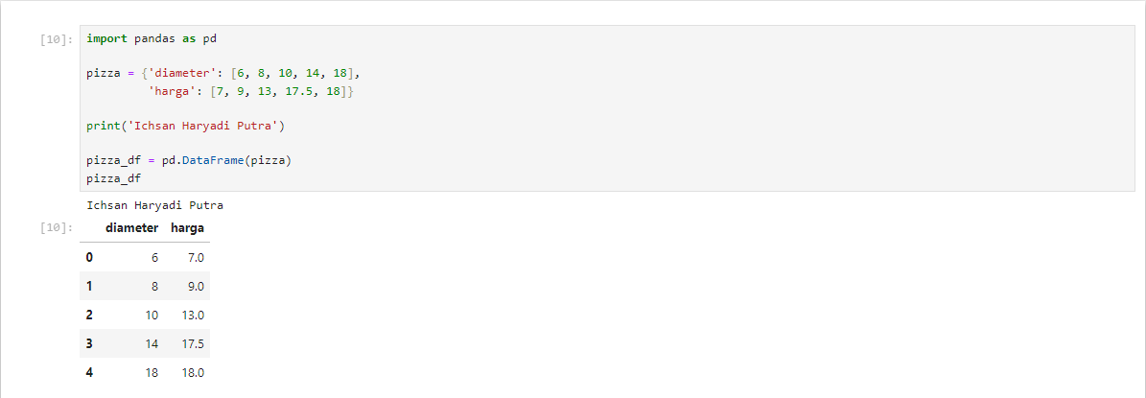

* Visualisasi Data

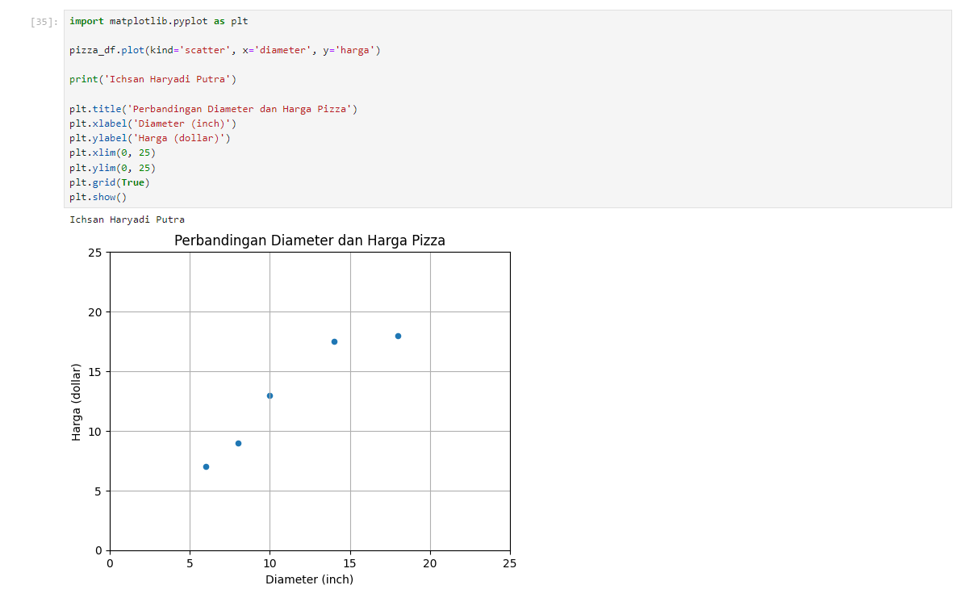

* Transformasi Data

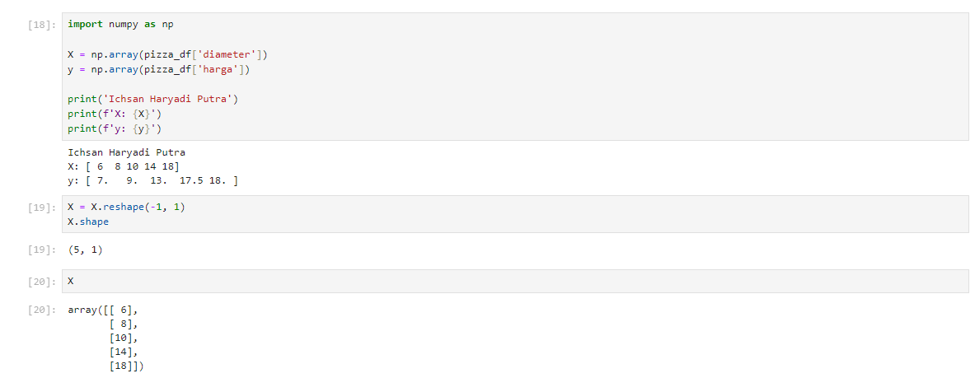

* Training Simple Linear Regression Model

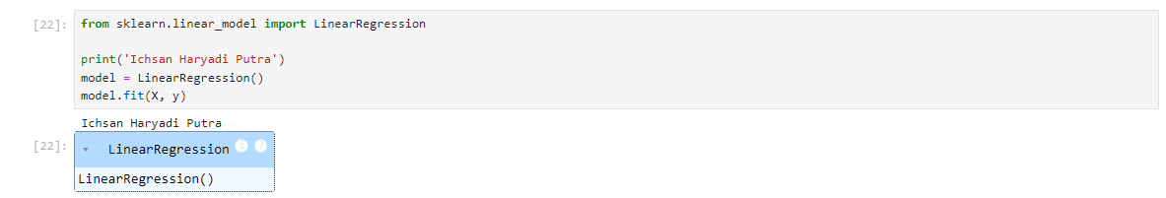

* Visualisasi Simple Linear Regression Model | Penjelasan persamaan garis linear

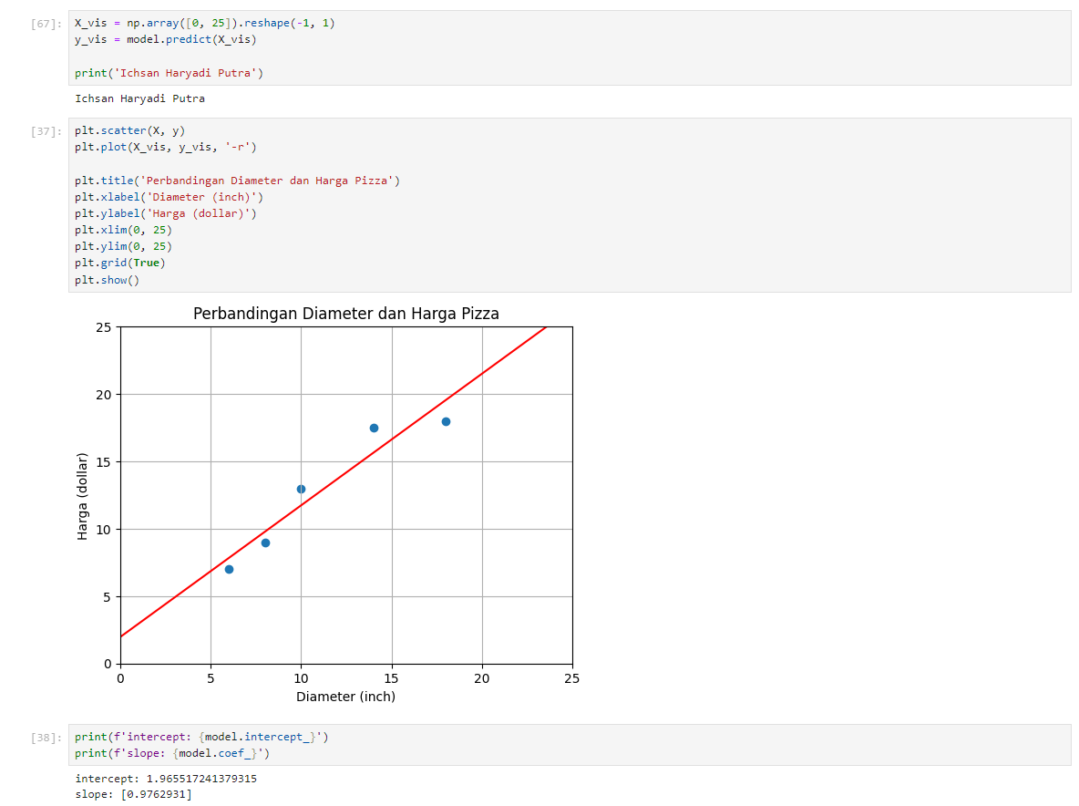

* Kalkulasi nilai slope

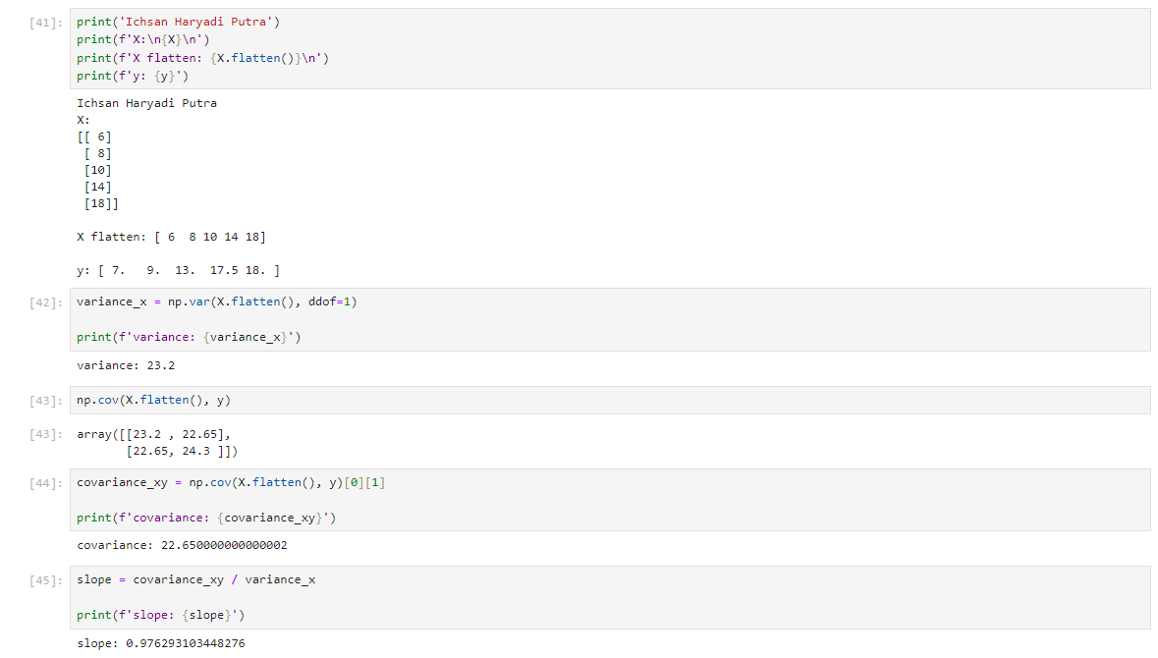

* Kalkukasi nilai intercept

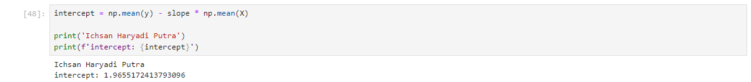

* Prediksi harga pizza dengan Simple Linear Regression Model

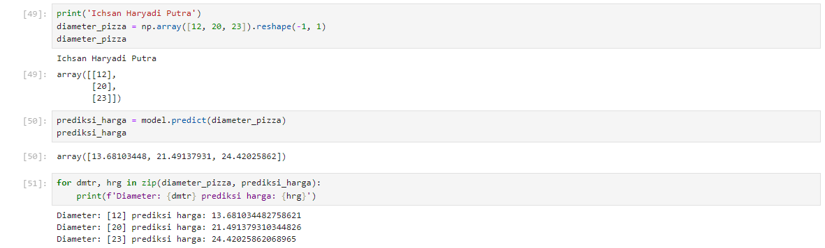

* Evaluasi model dengan Coefficient of Determination | R Squared

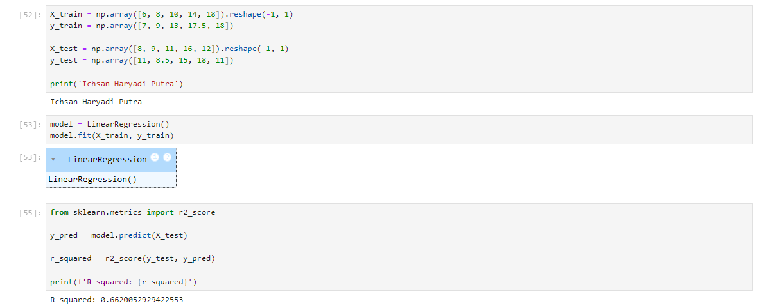

* Kalkulasi nilai R Squared | Coefficient of Determination

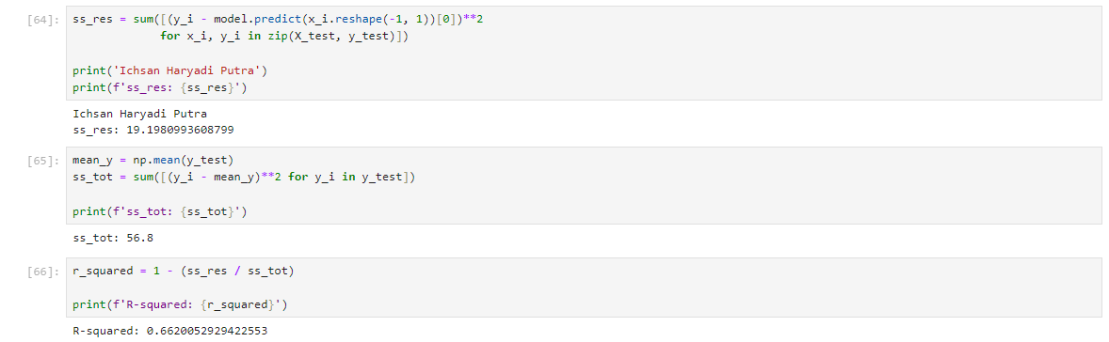

1. Praktek 2

* Persiapan sample dataset

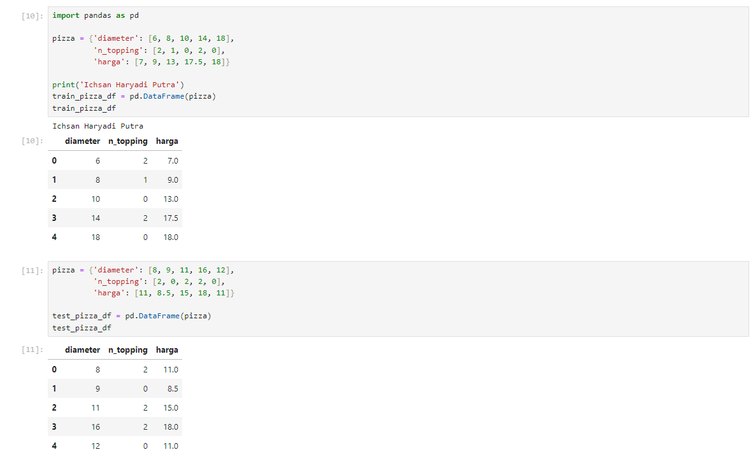

* Preprocessing dataset

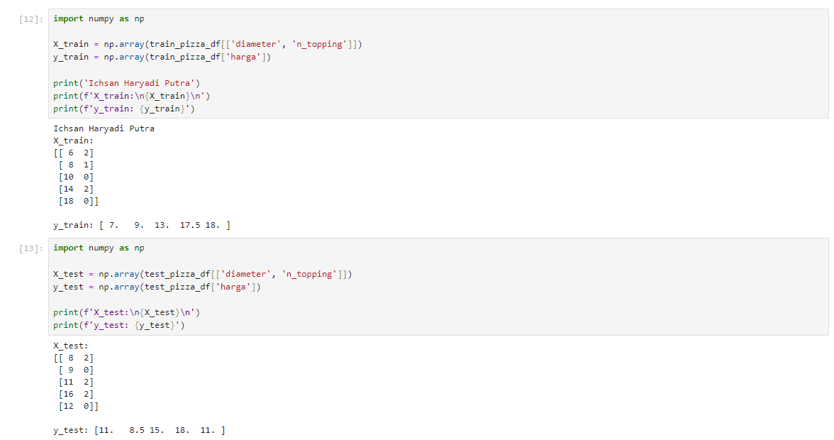

* Pengenalan Multiple Linear Regression

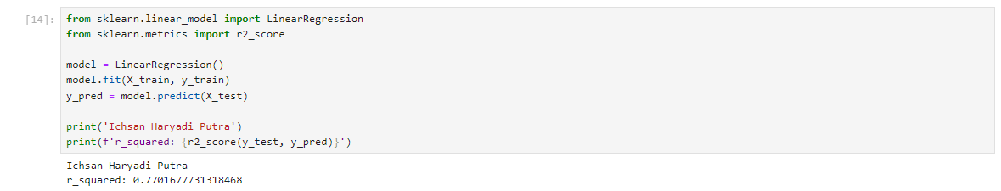

* Pengenalan Polynomial Regression

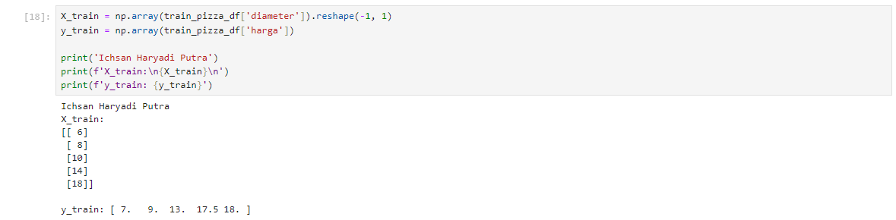

* Quadratic Polynomial Regression

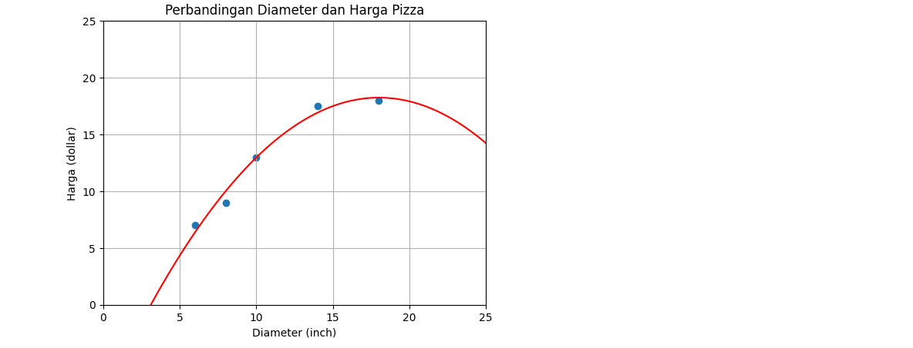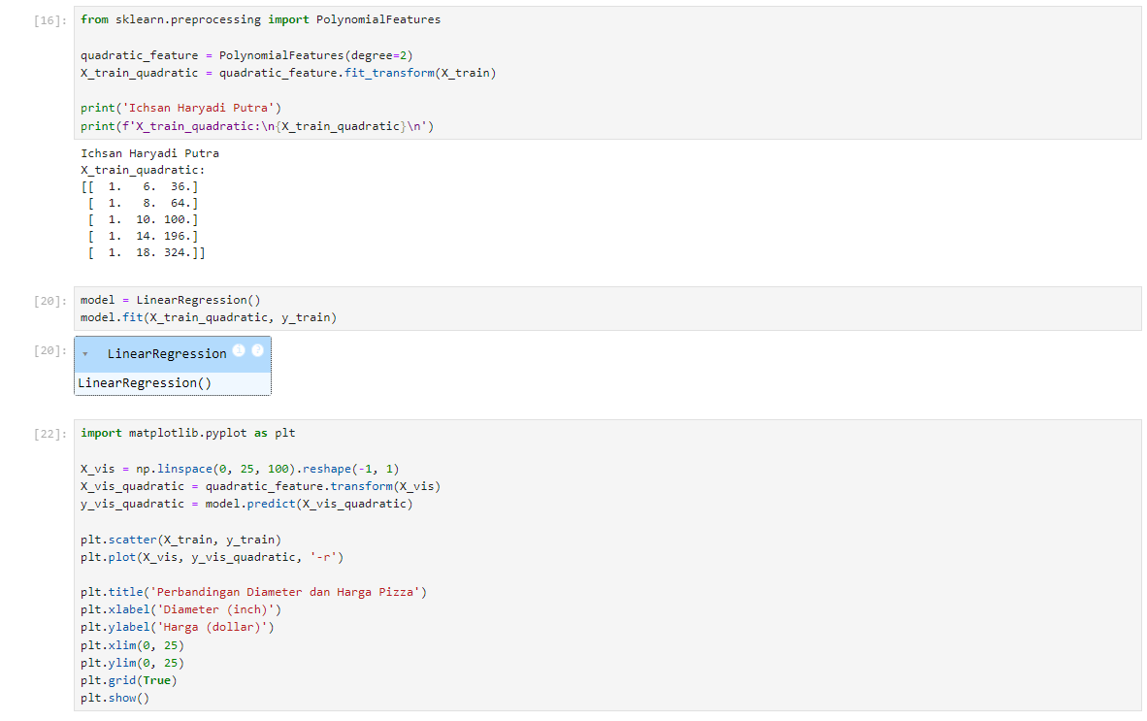

* Linear Regression vs Quadratic Polynomial Regression vs Cubic Polynomial Regression

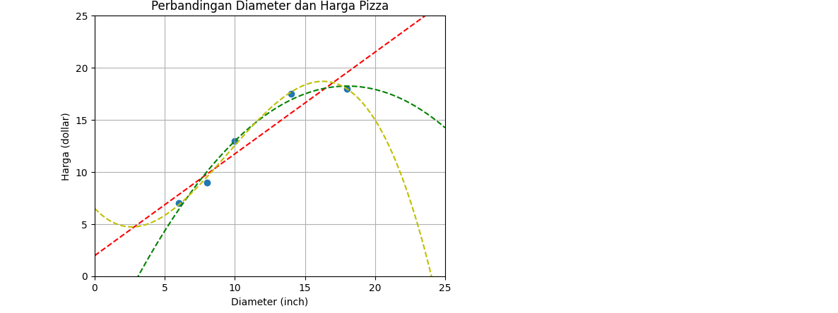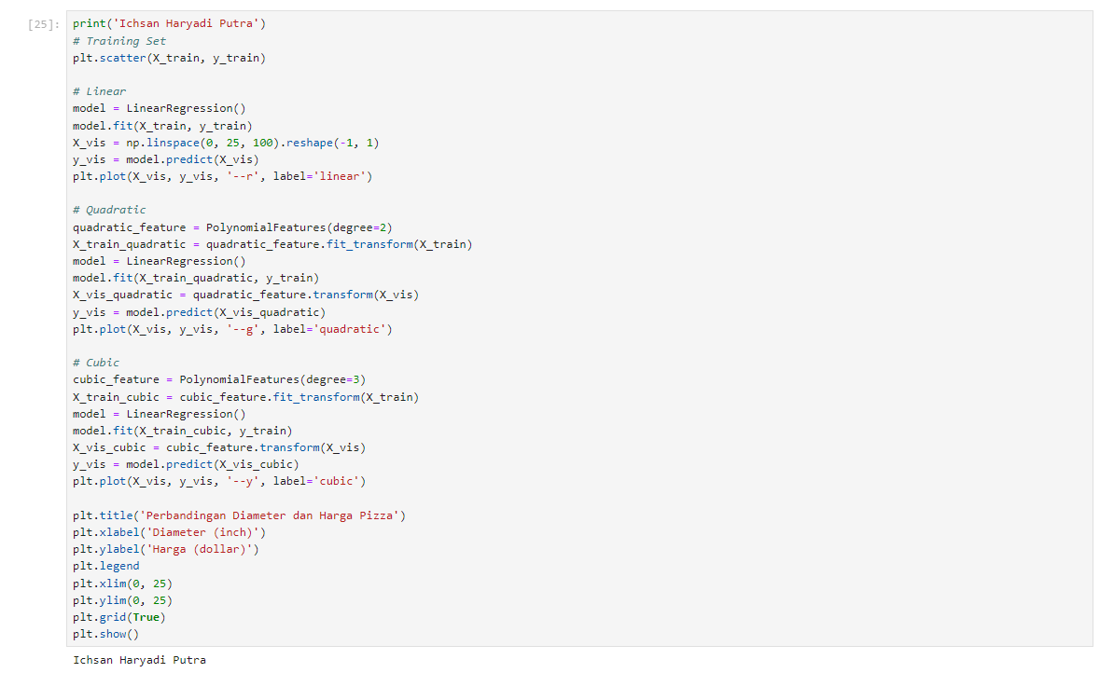

1. Praktek 3

* Persiapan dataset | SMS Spam Collection Dataset

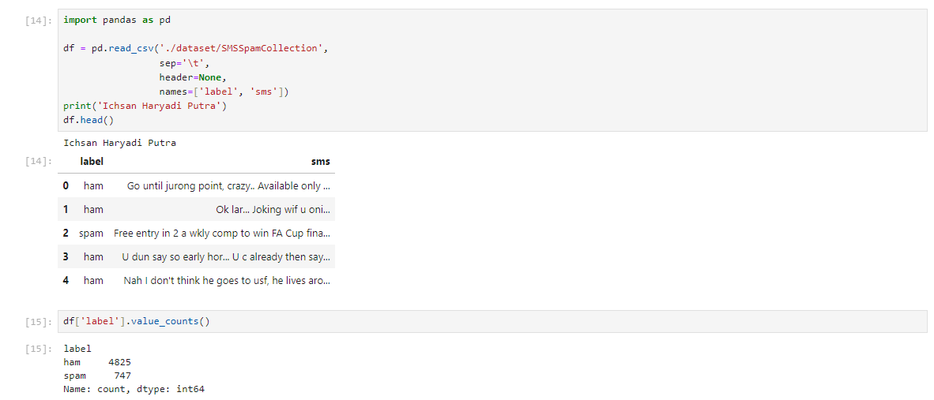

* Pembagian training dan testing set

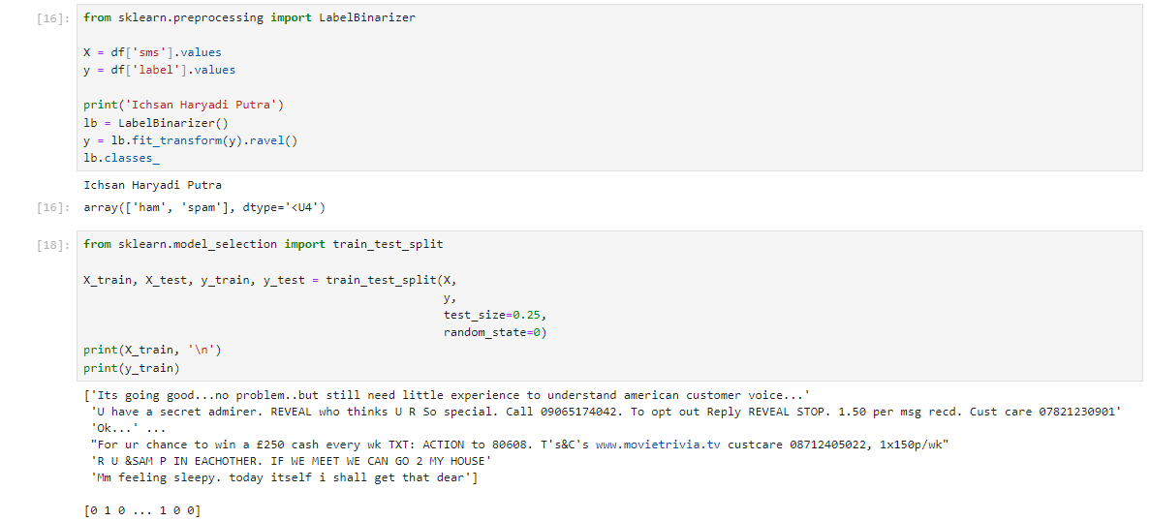

* Feature extraction dengan TF-IDF

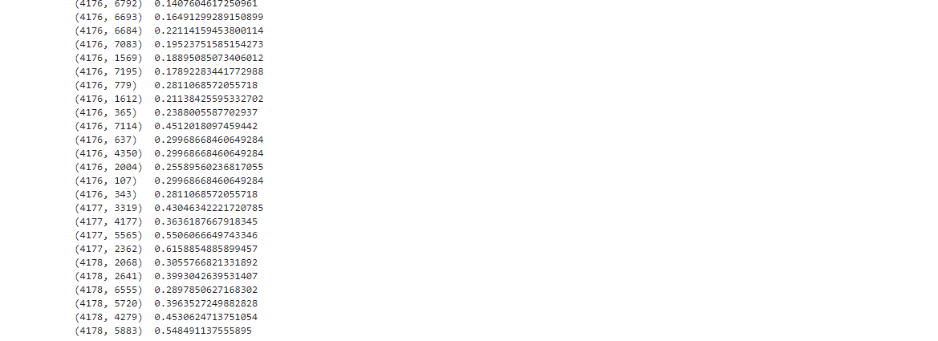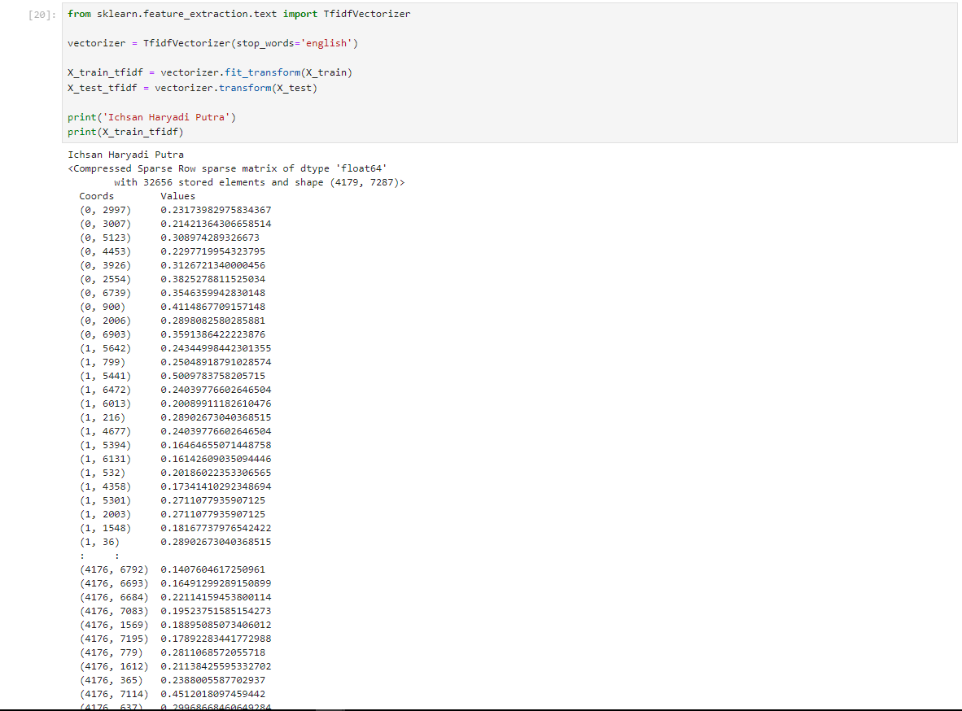

* Binary Classification dengan Logistic Regression

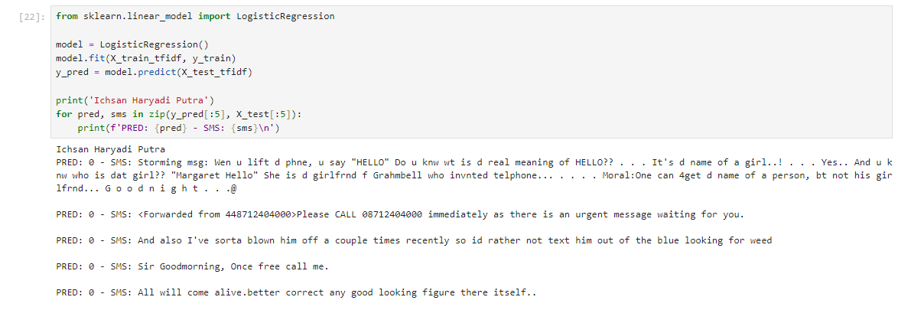

* Evaluation Metrics pada Binary Classification Task

1. Pengenalan Confusion Matrix

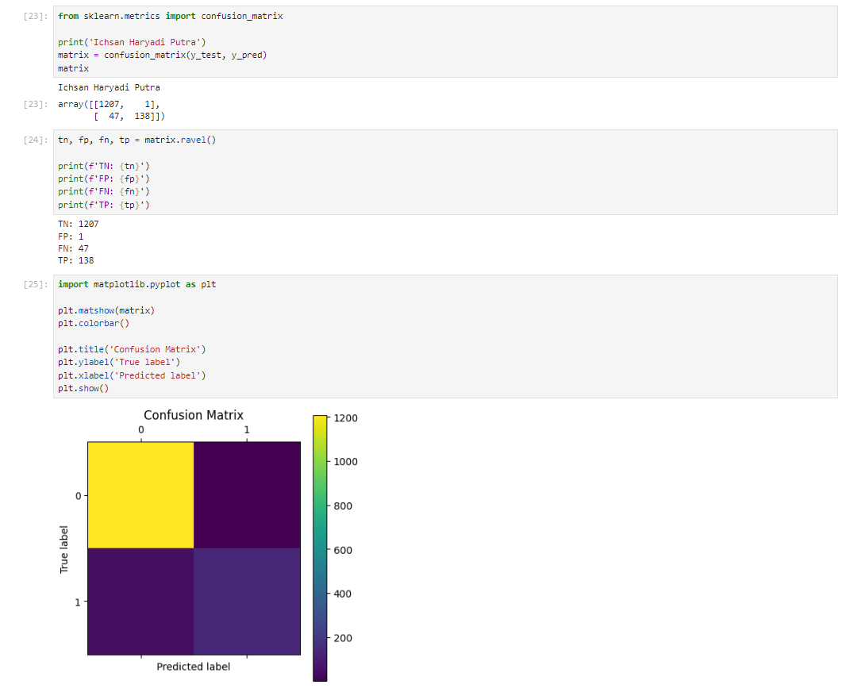

1. Pengenalan Accuracy Score

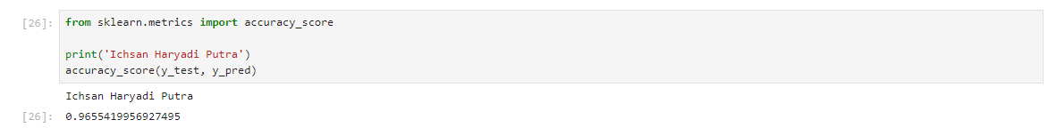

1. Pengenalan Precision dan Recall

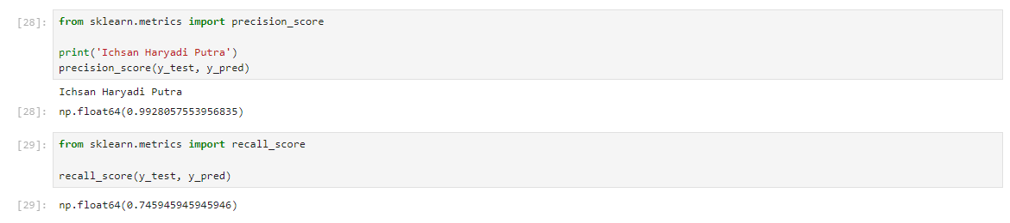

1. Pengenalan F1 Score | F1 Measure

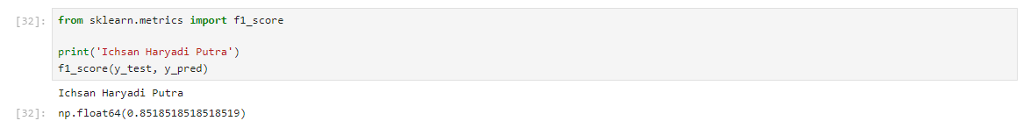

1. Pengenalan ROC | Receiver Operating Characteristic

